**Coding:** **//ListBox Application #Visual C++**

#include<afxwin.h>

class Mylistbox : public CFrameWnd {

CListBox list;

CButton ins, del, cnt, res;

CEdit txt;

CString str;

public:

Mylistbox() {

CString myclass;

myclass = AfxRegisterWndClass(CS_HREDRAW | CS_VREDRAW, 0, (HBRUSH)::GetStockObject(GRAY_BRUSH), 0);

Create(myclass, "List Box Applications");

}

int OnCreate(LPCREATESTRUCT lpCreateStruct)

{

CFrameWnd::OnCreate(lpCreateStruct);

txt.Create(WS_CHILD | WS_VISIBLE, CRect(100, 30, 300, 50), this, 9);

list.CreateEx(WS_EX_CLIENTEDGE, "LISTBOX", NULL, WS_CHILD | WS_VISIBLE | LBS_STANDARD, CRect(100, 70, 350, 220), this, 1);

ins.Create("INSERT", WS_CHILD | WS_VISIBLE | BS_PUSHBUTTON, CRect(360, 70, 500, 95), this, 2);

del.Create("DELETE", WS_CHILD | WS_VISIBLE | BS_PUSHBUTTON, CRect(360, 100, 500, 125), this, 3);

cnt.Create("COUNT", WS_CHILD | WS_VISIBLE | BS_PUSHBUTTON, CRect(360, 130, 500, 155), this, 4);

res.Create("RESET", WS_CHILD | WS_VISIBLE | BS_PUSHBUTTON, CRect(360, 160, 500, 185), this, 5);

return 0;

}

void insertitems()

{

txt.GetWindowText(str);

int index = list.GetCurSel();

list.InsertString(index, str);

}

void deleteitems()

{

int index = list.GetCurSel();

list.DeleteString(index);

}

void countitems()

{

int max = list.GetCount();

char msg[80];

sprintf_s(msg, "%d Items are available in the listbox", max);

MessageBox(msg, "Count");

}

void resetitems()

{

list.ResetContent();

}

void selecteditem()

{

CString sitem;

int index = list.GetCurSel();

list.GetText(index, sitem);

sitem = "Item :" + sitem;

MessageBox(sitem, " is the Currently selected item in listbox");

}

DECLARE_MESSAGE_MAP()

};

BEGIN_MESSAGE_MAP(Mylistbox, CFrameWnd)

ON_WM_CREATE()

ON_LBN_SELCHANGE(1, selecteditem)

ON_COMMAND(2, insertitems)

ON_COMMAND(3, deleteitems)

ON_COMMAND(4, countitems)

ON_COMMAND(5, resetitems)

END_MESSAGE_MAP()

class Myapp : public CWinApp

{

public:

int InitInstance()

{

Mylistbox*mlb = new Mylistbox;

mlb->ShowWindow(3);

m_pMainWnd = mlb;

return -1;

}

};

Myapp m;

**Output:**

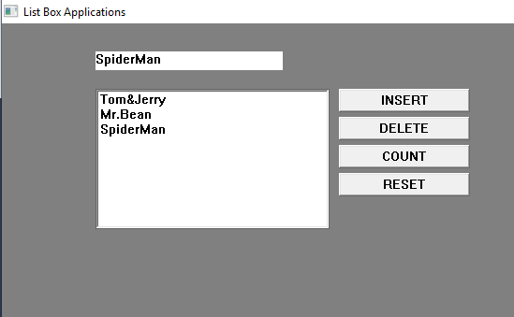

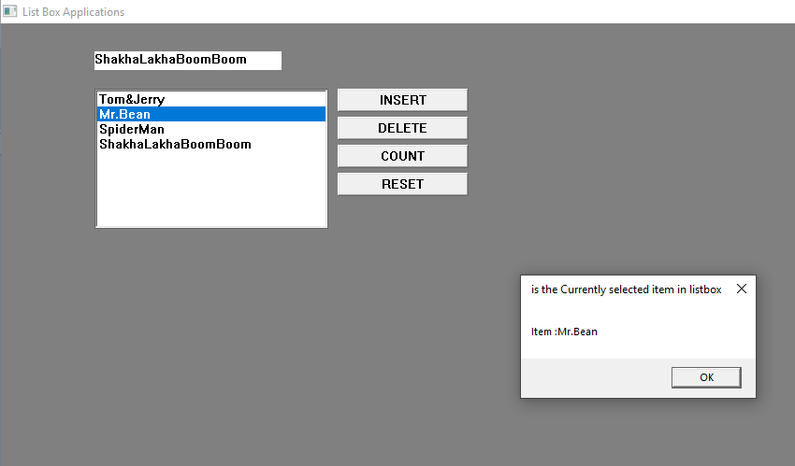

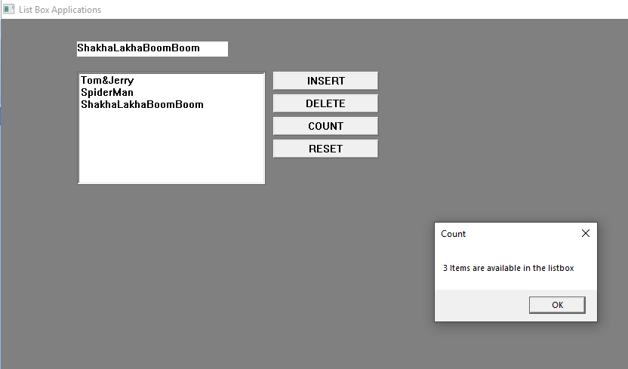

**Coding: //Animation #Visual C++**

#include<afxwin.h>

#include"resource.h"

class pgm4 :public CFrameWnd

{

int x;

public:

pgm4()

{

Create(0, _T("ANIMATION OF AN OBJECT.."));

SetTimer(1, 100, 0);

x = 0;

}

int OnEraseBkgnd(CDC *d)

{

CRect r;

GetClientRect(&r);

CBrush mybrush(RGB(255, 255, 255));

d->SelectObject(&mybrush);

d->FillRect(&r, &mybrush);

CDC c;

CBitmap mybitmap;

mybitmap.LoadBitmap(IDB_BITMAP1);

c.CreateCompatibleDC(d);

c.SelectObject(&mybitmap);

d->BitBlt(x, 100, 50, 50, &c, 0, 0, SRCCOPY);

x = x + 10;

if (x > 1500)x = 0;

return 1;

}

void OnTimer(UINT_PTR)

{

Invalidate();

}

DECLARE_MESSAGE_MAP()

};

BEGIN_MESSAGE_MAP(pgm4, CFrameWnd)

ON_WM_ERASEBKGND()

ON_WM_TIMER()

END_MESSAGE_MAP()

class mywindow :public CWinApp

{

public:

int InitInstance()

{

pgm4 *pg = new pgm4;

m_pMainWnd = pg;

pg->ShowWindow(3);

return 1;

}

};

mywindow mw;

**Output:**

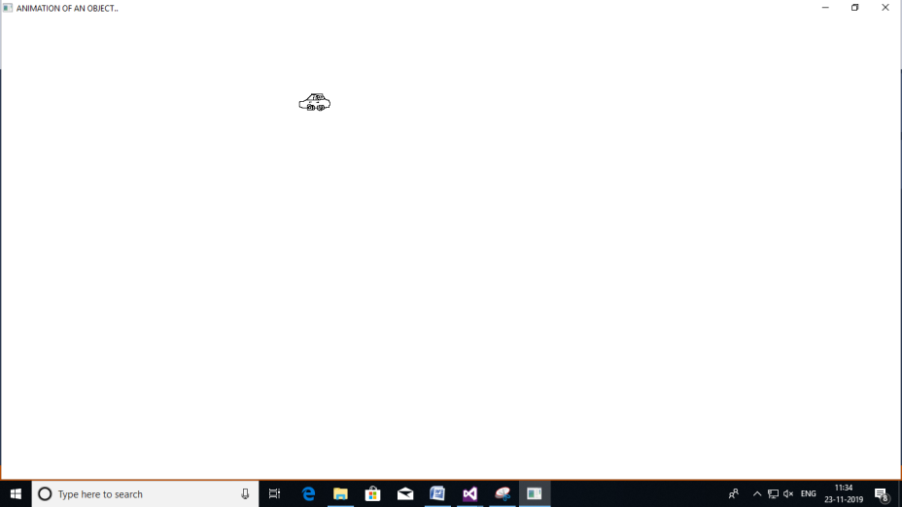

**Coding: //Drawing Circles #Visual C++**

#include<afxwin.h>

class pgm1 : public CFrameWnd

{

public:

pgm1()

{

Create(NULL, _T("DRAWING CIRCLES"));

}

void OnLButtonDown(UINT u, CPoint pt)

{

CClientDC d(this);

CBrush cb;

CPen cp;

cb.CreateSolidBrush(RGB(200, 244, 200));

cp.CreatePen(PS_SOLID, 4, RGB(0, 255, 0));

d.SelectObject(&cb);

d.SelectObject(&cp);

d.Ellipse(pt.x, pt.y, pt.x + 50, pt.y + 50);

}

DECLARE_MESSAGE_MAP()

};

BEGIN_MESSAGE_MAP(pgm1, CFrameWnd)

ON_WM_LBUTTONDOWN()

END_MESSAGE_MAP()

class mywindow : public CWinApp

{

public:

int InitInstance()

{

pgm1 *pg = new pgm1;

m_pMainWnd = pg;

pg->ShowWindow(1);

return 1;

}

};

mywindow mw;

**Output:**

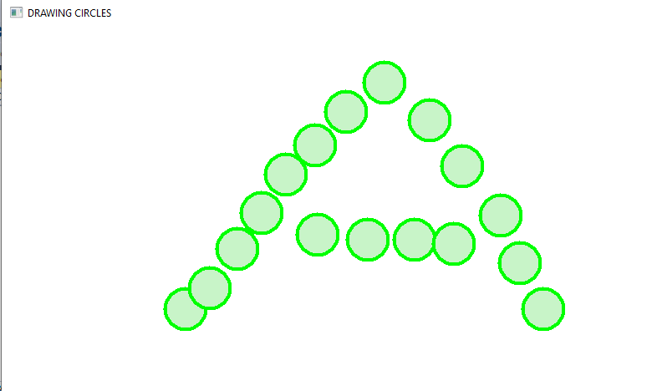

**Coding: //Implementing Message Map #Visual C++**

#include<afxwin.h>

class pgm2 : public CFrameWnd

{

public:

pgm2()

{

Create(0, _T("IMPLEMENTING MESSAGE MAP"));

}

void OnLButtonDown(UINT u, CPoint pt)

{

char msg[50];

sprintf_s(msg, "Left Button is pressed at (%d,%d)", pt.x, pt.y);

CClientDC d(this);

d.TextOut(pt.x, pt.y, msg);

}

void OnRButtonDown(UINT u, CPoint pt)

{

char msg[50];

sprintf_s(msg, "Right Button is pressed at (%d,%d)", pt.x, pt.y);

CClientDC d(this);

d.TextOut(pt.x, pt.y, msg);

}

DECLARE_MESSAGE_MAP()

};

BEGIN_MESSAGE_MAP(pgm2, CFrameWnd)

ON_WM_LBUTTONDOWN()

ON_WM_RBUTTONDOWN()

END_MESSAGE_MAP()

class mywindow : public CWinApp

{

public:

int InitInstance()

{

pgm2* pg = new pgm2;

m_pMainWnd = pg;

pg->ShowWindow(1);

return 1;

}

};

mywindow mw;

**Output:**

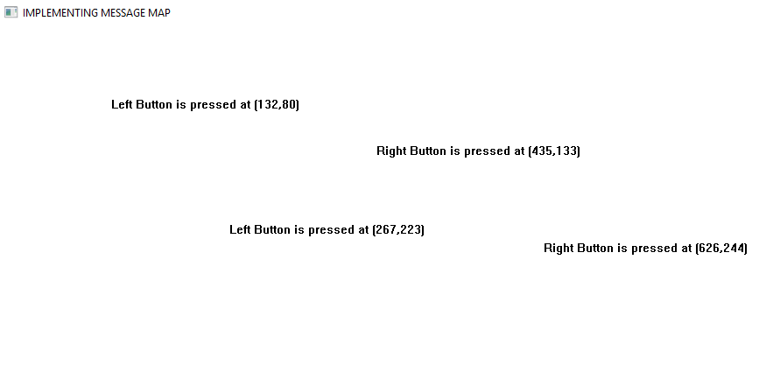

**Coding: //Paint Window #Visual C++**

#include<afxwin.h>

class paintb : public CFrameWnd

{

CPoint m_StartPoint, m_EndPoint;

public:

paintb()

{

Create(NULL, _T("paintb Window"));

}

void OnLButtonDown(UINT nFlags, CPoint point);

void OnLButtonUp(UINT nFlags, CPoint point);

DECLARE_MESSAGE_MAP()

};

BEGIN_MESSAGE_MAP(paintb, CFrameWnd)

ON_WM_LBUTTONDOWN()

ON_WM_LBUTTONUP()

END_MESSAGE_MAP()

void paintb::OnLButtonDown(UINT nFlags, CPoint point)

{

CFrameWnd::OnLButtonDown(nFlags, point);

m_StartPoint = point;

}

void paintb::OnLButtonUp(UINT nFlags, CPoint point)

{

CFrameWnd::OnLButtonDown(nFlags, point);

m_EndPoint = point;

CClientDC dc(this);

dc.MoveTo(m_StartPoint);

dc.LineTo(m_EndPoint);

}

class Myapp :public CWinApp

{

public:

BOOL InitInstance()

{

m_pMainWnd = new paintb();

m_pMainWnd->ShowWindow(1);

return 1;

}

};

Myapp theapp;

**Output:**

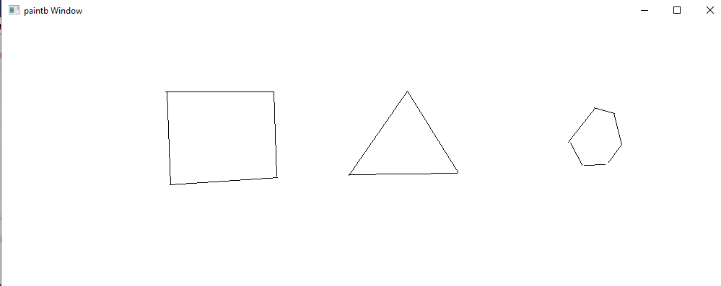

**Form Design: //Notepad #VB .Net**

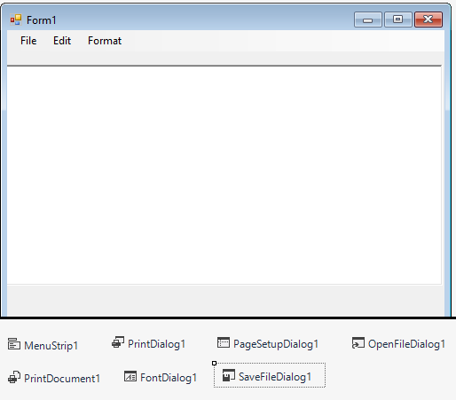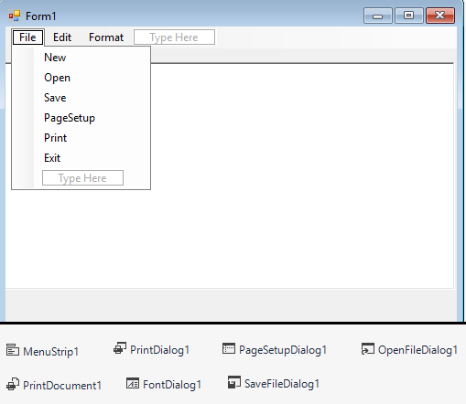

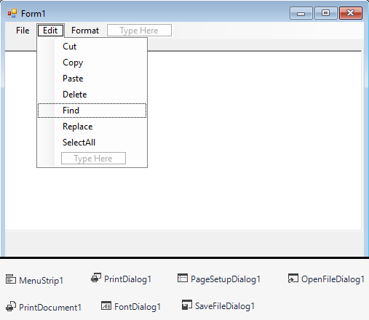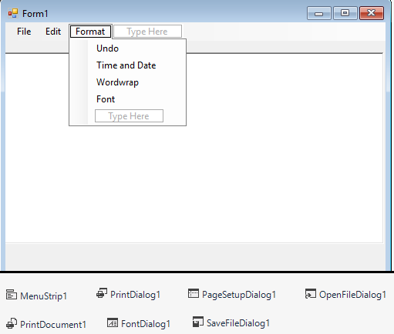

**Coding:**

Public Class Form1

Inherits System.Windows.Forms.Form

Dim pgset As New PageSetupDialog

Dim opdg As New OpenFileDialog

Dim sdg As New SaveFileDialog

Dim pd As New PrintDialog

Dim flgsave As Integer

Dim fndtxt As String

Dim rpltxt As String

Dim fd As New FontDialog

Dim rtb As New RichTextBox

Private Sub NewToolStripMenuItem_Click(sender As Object, e As EventArgs) Handles NewToolStripMenuItem.Click

RichTextBox1.Text = ""

RichTextBox1.Focus()

Form.ActiveForm.Text = ""

'Me.text="untitled-notepad"

flgsave = 0

End Sub

Private Sub OpenToolStripMenuItem_Click(sender As Object, e As EventArgs) Handles OpenToolStripMenuItem.Click

opdg.ShowDialog()

Me.RichTextBox1.LoadFile(opdg.FileName)

End Sub

Private Sub SaveToolStripMenuItem_Click(sender As Object, e As EventArgs) Handles SaveToolStripMenuItem.Click

'sdg.filter="(*.*)all files(*.text)text files(*.rtf)"

sdg.ShowDialog(Form1.ActiveForm)

Me.RichTextBox1.SaveFile(sdg.FileName)

Me.Text = sdg.FileName

End Sub

Private Sub PageSetupToolStripMenuItem_Click(sender As Object, e As EventArgs) Handles PageSetupToolStripMenuItem.Click

PrintDocument1.DocumentName = RichTextBox1.Text

pgset.Document = PrintDocument1

pgset.ShowDialog()

End Sub

Private Sub PrintToolStripMenuItem_Click(sender As Object, e As EventArgs) Handles PrintToolStripMenuItem.Click

PrintDocument1.DocumentName = RichTextBox1.Text

pd.Document = PrintDocument1

pd.ShowDialog()

End Sub

Private Sub ExitToolStripMenuItem_Click(sender As Object, e As EventArgs) Handles ExitToolStripMenuItem.Click

Close()

End Sub

Private Sub CutToolStripMenuItem_Click(sender As Object, e As EventArgs) Handles CutToolStripMenuItem.Click

RichTextBox1.Cut()

End Sub

Private Sub CopyToolStripMenuItem_Click(sender As Object, e As EventArgs) Handles CopyToolStripMenuItem.Click

RichTextBox1.Copy()

End Sub

Private Sub PasteToolStripMenuItem_Click(sender As Object, e As EventArgs) Handles PasteToolStripMenuItem.Click

RichTextBox1.Paste()

End Sub

Private Sub DeleteToolStripMenuItem_Click(sender As Object, e As EventArgs) Handles DeleteToolStripMenuItem.Click

RichTextBox1.SelectedText = ""

End Sub

Private Sub FindToolStripMenuItem_Click(sender As Object, e As EventArgs) Handles FindToolStripMenuItem.Click

fndtxt = InputBox("Find What?", "FIND")

RichTextBox1.Find(fndtxt, 0)

End Sub

Private Sub ReplaceToolStripMenuItem_Click(sender As Object, e As EventArgs) Handles ReplaceToolStripMenuItem.Click

fndtxt = InputBox("Find What?", "FIND")

rpltxt = InputBox("Replace with", "Replace")

RichTextBox1.Find(fndtxt, 0)

RichTextBox1.SelectedText = rpltxt

End Sub

Private Sub SelectAllToolStripMenuItem_Click(sender As Object, e As EventArgs) Handles SelectAllToolStripMenuItem.Click

RichTextBox1.SelectAll()

End Sub

Private Sub UndoToolStripMenuItem1_Click(sender As Object, e As EventArgs) Handles UndoToolStripMenuItem1.Click

RichTextBox1.Undo()

End Sub

Private Sub TimeAndDateToolStripMenuItem_Click(sender As Object, e As EventArgs) Handles TimeAndDateToolStripMenuItem.Click

RichTextBox1.SelectedText = Now

End Sub

Private Sub WordwrapToolStripMenuItem_Click(sender As Object, e As EventArgs) Handles WordwrapToolStripMenuItem.Click

If WordwrapToolStripMenuItem.Checked = False Then

WordwrapToolStripMenuItem.Checked = True

Else

RichTextBox1.WordWrap = True

End If

End Sub

Private Sub FontToolStripMenuItem_Click(sender As Object, e As EventArgs) Handles FontToolStripMenuItem.Click

fd.ShowDialog()

RichTextBox1.Font = fd.Font

End Sub

End Class

**Output:**

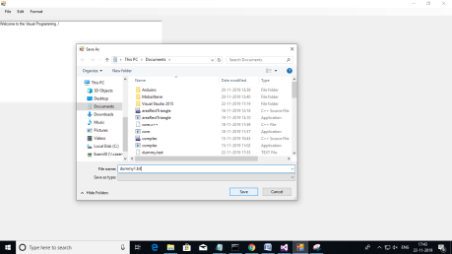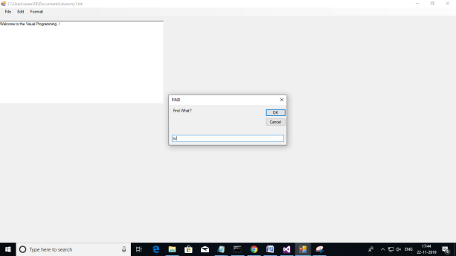

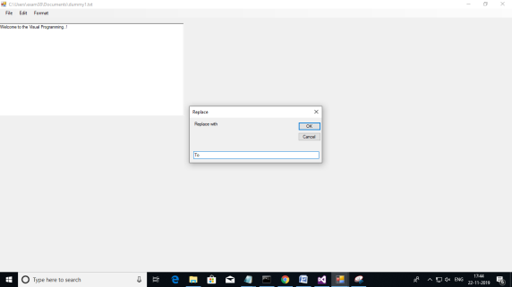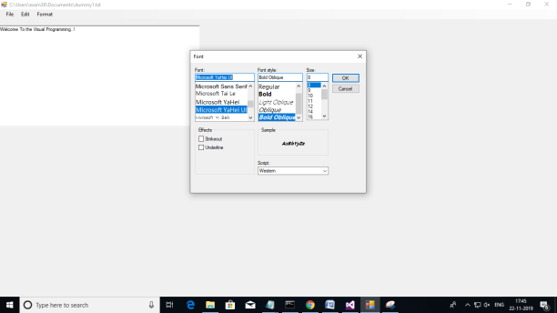

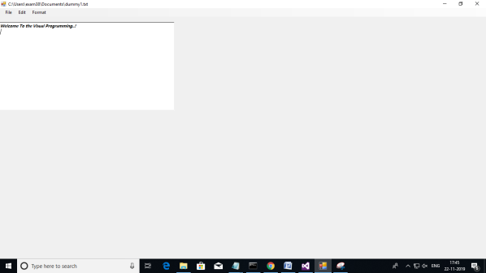

**Form Design: //Font Application #VB .Net**

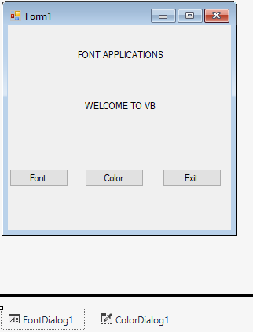

**Coding:**

Public Class Form1

Dim fd As New FontDialog

Dim cd As New ColorDialog

Private Sub Button1_Click(sender As Object, e As EventArgs) Handles Button1.Click

fd.ShowDialog()

Label2.Font = fd.Font

Label2.AutoSize = True

End Sub

Private Sub Button2_Click(sender As Object, e As EventArgs) Handles Button2.Click

cd.ShowDialog()

Label2.ForeColor = cd.Color

cd.ShowDialog()

Label2.BackColor = cd.Color

End Sub

Private Sub Button3_Click(sender As Object, e As EventArgs) Handles Button3.Click

End

End Sub

End Class

**Output:**

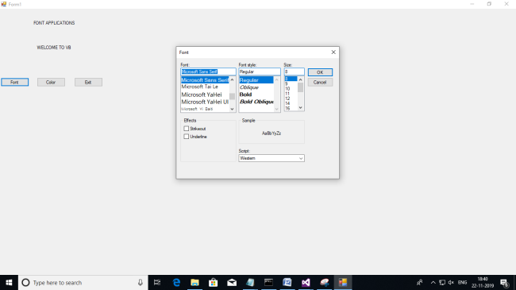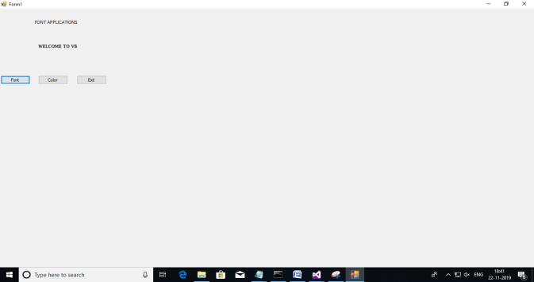

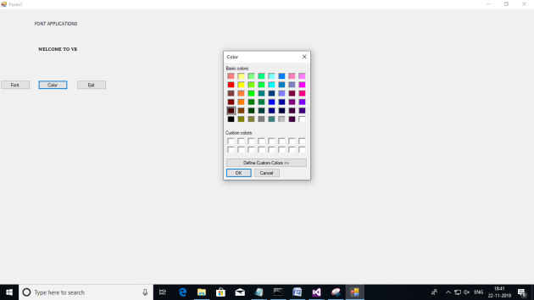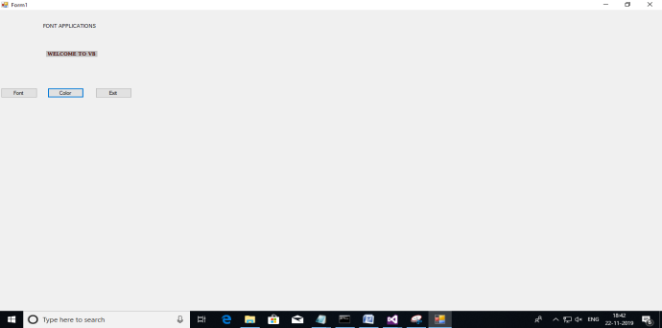

**Form Design: //TextFile Creation #VB .Net**

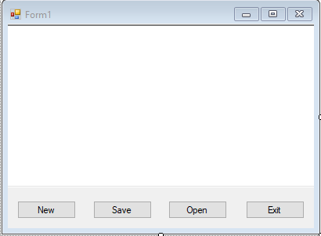

**Coding:**

Public Class Form1

Private Sub Button1_Click(sender As Object, e As EventArgs) Handles Button1.Click

RichTextBox1.Text = ""

End Sub

Private Sub Button2_Click(sender As Object, e As EventArgs) Handles Button2.Click

Dim savetxt As New SaveFileDialog

savetxt.Filter = "Text(*.txt)|*.txt|rtf(plaintext)|*.rtf"

savetxt.ShowDialog()

MsgBox(savetxt.FileName)

If savetxt.FileName = "" Then

MsgBox("Error: Path not found", MsgBoxStyle.Critical, "Error")

Else

Dim save As New IO.StreamWriter(savetxt.FileName)

save.Write(RichTextBox1.Text)

save.Close()

End If

End Sub

Private Sub Button3_Click(sender As Object, e As EventArgs) Handles Button3.Click

Dim opentxt As New OpenFileDialog

opentxt.Filter = "Text(*.txt)|*.txt|rtf(plaintext)|*.rtf"

opentxt.ShowDialog()

If opentxt.FileName = "" Then

Else

Dim open As New IO.StreamReader(opentxt.FileName)

RichTextBox1.Text = open.ReadToEnd

End If

End Sub

Private Sub Button4_Click(sender As Object, e As EventArgs) Handles Button4.Click

End

End Sub

End Class

**Output:**

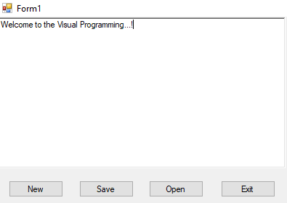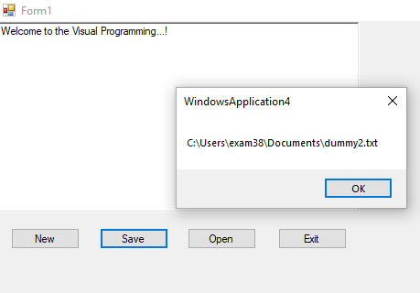

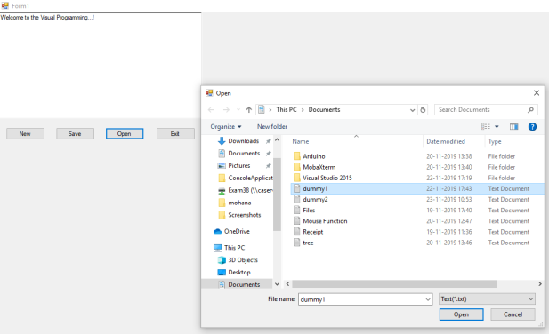 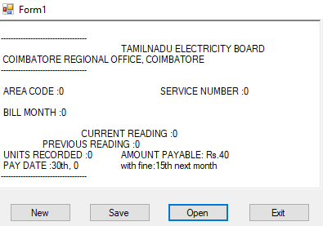

**Form Design: //Simple Calculator #VB .Net**

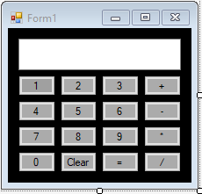

**Coding:**

Public Class Form1

Dim firstnumber As Long

Dim operation As String

Private Sub Button6_Click(sender As Object, e As EventArgs) Handles Button6.Click

If TextBox1.Text = "0" Then

TextBox1.Text = "5"

Else

TextBox1.Text = TextBox1.Text & "5"

End If

End Sub

Private Sub Button10_Click(sender As Object, e As EventArgs) Handles Button10.Click

If TextBox1.Text = "0" Then

TextBox1.Text = "8"

Else

TextBox1.Text = TextBox1.Text & "8"

End If

End Sub

Private Sub Button14_Click(sender As Object, e As EventArgs) Handles Button14.Click

TextBox1.Text = ""

End Sub

Private Sub Button15_Click(sender As Object, e As EventArgs) Handles Button15.Click

Dim secondnumber As Long

Dim result As Long

secondnumber = TextBox1.Text

If operation = "+" Then

result = firstnumber + secondnumber

ElseIf operation = "-" Then

result = firstnumber - secondnumber

ElseIf operation = "*" Then

result = firstnumber * secondnumber

ElseIf operation = "/" Then

result = firstnumber / secondnumber

End If

firstnumber = result

TextBox1.Text = result

End Sub

Private Sub Button1_Click(sender As Object, e As EventArgs) Handles Button1.Click

If TextBox1.Text = "0" Then

TextBox1.Text = "1"

Else

TextBox1.Text = TextBox1.Text & "1"

End If

End Sub

Private Sub Button2_Click(sender As Object, e As EventArgs) Handles Button2.Click

If TextBox1.Text = "0" Then

TextBox1.Text = "2"

Else

TextBox1.Text = TextBox1.Text & "2"

End If

End Sub

Private Sub Button3_Click(sender As Object, e As EventArgs) Handles Button3.Click

If TextBox1.Text = "0" Then

TextBox1.Text = "3"

Else

TextBox1.Text = TextBox1.Text & "3"

End If

End Sub

Private Sub Button5_Click(sender As Object, e As EventArgs) Handles Button5.Click

If TextBox1.Text = "0" Then

TextBox1.Text = "4"

Else

TextBox1.Text = TextBox1.Text & "4"

End If

End Sub

Private Sub Button7_Click(sender As Object, e As EventArgs) Handles Button7.Click

If TextBox1.Text = "0" Then

TextBox1.Text = "6"

Else

TextBox1.Text = TextBox1.Text & "6"

End If

End Sub

Private Sub Button9_Click(sender As Object, e As EventArgs) Handles Button9.Click

If TextBox1.Text = "0" Then

TextBox1.Text = "7"

Else

TextBox1.Text = TextBox1.Text & "7"

End If

End Sub

Private Sub Button11_Click(sender As Object, e As EventArgs) Handles Button11.Click

If TextBox1.Text = "0" Then

TextBox1.Text = "9"

Else

TextBox1.Text = TextBox1.Text & "9"

End If

End Sub

Private Sub Button13_Click(sender As Object, e As EventArgs) Handles Button13.Click

If TextBox1.Text = "0" Then

TextBox1.Text = "0"

Else

TextBox1.Text = TextBox1.Text & "0"

End If

End Sub

Private Sub Button4_Click(sender As Object, e As EventArgs) Handles Button4.Click

firstnumber = TextBox1.Text

TextBox1.Text = ""

operation = "+"

End Sub

Private Sub Button8_Click(sender As Object, e As EventArgs) Handles Button8.Click

firstnumber = TextBox1.Text

TextBox1.Text = ""

operation = "-"

End Sub

Private Sub Button12_Click(sender As Object, e As EventArgs) Handles Button12.Click

firstnumber = TextBox1.Text

TextBox1.Text = ""

operation = "*"

End Sub

Private Sub Button16_Click(sender As Object, e As EventArgs) Handles Button16.Click

firstnumber = TextBox1.Text

TextBox1.Text = ""

operation = "/"

End Sub

End Class

**Output:**

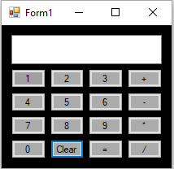 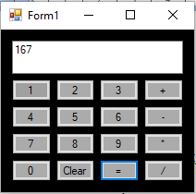

**Form Design: //NewsPaper Vendor Details #VB .Net**

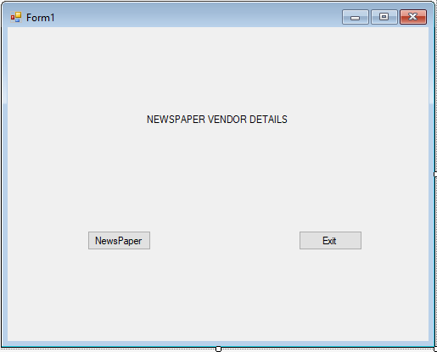

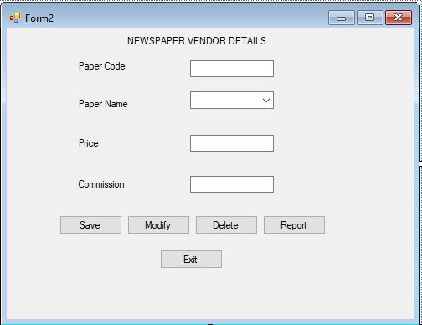

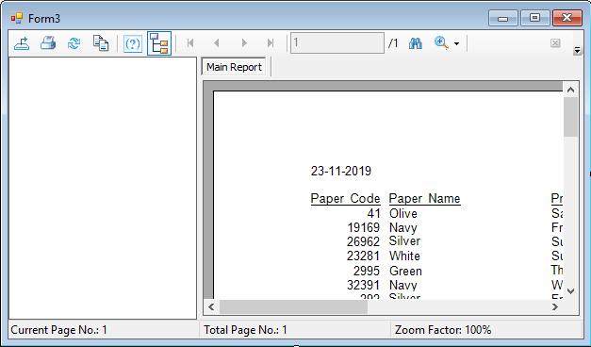

**Coding:**

**Form 1:**

Public Class Form1

Inherits System.Windows.Forms.Form

Private Sub Button1_Click(sender As Object, e As EventArgs) Handles Button1.Click

Form2.Show()

End Sub

Private Sub Button2_Click(sender As Object, e As EventArgs) Handles Button2.Click

End

End Sub

End Class

**Form 2:**

Imports System.Data.OleDb

Public Class Form2

Inherits System.Windows.Forms.Form

Dim cmd As OleDbCommand

Dim dread As OleDbDataReader

Dim pc, pn, sql As String

Dim pr, co As Double

Dim con As New OleDbConnection("Provider=Microsoft.Jet.OLEDB.4.0;Data Source=Z:\News.mdb")

Sub movedata()

pc = Val(TextBox1.Text)

pn = ComboBox1.Text

pr = Val(TextBox2.Text)

co = Val(TextBox3.Text)

End Sub

Sub displaydata()

TextBox1.Text = dread(0)

ComboBox1.Text = dread(1)

TextBox2.Text = dread(2)

TextBox3.Text = dread(3)

End Sub

Sub clearfields()

TextBox1.Text = ""

ComboBox1.Text = ""

TextBox2.Text = ""

TextBox3.Text = ""

End Sub

Private Sub Button1_Click(sender As Object, e As EventArgs) Handles Button1.Click

movedata()

con.Open()

sql = "insert into News values('" & pc & "', '" & pn & "','" & pr & "','" & co & "')"

cmd = New OleDbCommand(sql, con)

cmd.ExecuteNonQuery()

con.Close()

MsgBox("The given paper details are stored", MsgBoxStyle.Information, "Save")

clearfields()

End Sub

Private Sub Button2_Click(sender As Object, e As EventArgs) Handles Button2.Click

movedata()

con.Open()

sql = "update News set Paper_Name='" & pn & "',Price= " & pr & " ,Commission=" & co & " where Paper_Code=" & pc & " "

cmd = New OleDbCommand(sql, con)

cmd.ExecuteNonQuery()

con.Close()

MsgBox("The given paper details is modified", MsgBoxStyle.Information, "Modified")

clearfields()

End Sub

Private Sub Button3_Click(sender As Object, e As EventArgs) Handles Button3.Click

con.Open()

sql = "Delete from News where Paper_Code=" & TextBox1.Text & ""

cmd = New OleDbCommand(sql, con)

cmd.ExecuteNonQuery()

con.Close()

MsgBox("The given details is deleted", MsgBoxStyle.Information, "Save")

clearfields()

End Sub

Private Sub Button4_Click(sender As Object, e As EventArgs) Handles Button4.Click

Form3.Show()

End Sub

Private Sub Button5_Click(sender As Object, e As EventArgs) Handles Button5.Click

Me.Dispose()

End Sub

Private Sub TextBox1_Leave(ByVal sender As Object, ByVal e As System.EventArgs) Handles TextBox1.Leave

sql = "select * from News where Paper_Code=" & Val(TextBox1.Text) & ""

con.Open()

cmd = New OleDbCommand(sql, con)

dread = cmd.ExecuteReader

If dread.HasRows = True Then

dread.Read()

displaydata()

End If

dread.Close()

con.Close()

End Sub

End Class

**Output:**

